Ultrasonic Extruder Components:

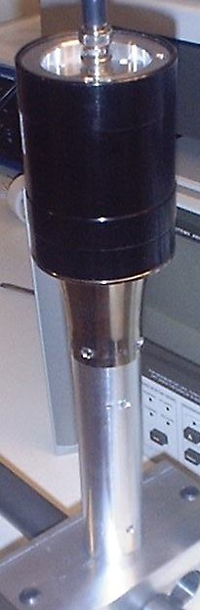

Ultrasonic Converter:
Length 6 inches plus connector and cable

Aluminum Wave Guide:
Length 3 to 6 inches

